
PLANT THE FUTURE
A Concept Note
A phased approach to building an organic coconut oil plantation and processing factory in Maryland County, Liberia
A single coconut tree will bear fruit for eighty years, which is long enough to carry a farming family through three generations. “Plant the Future” is Universal Outreach Foundation's initiative to turn that simple fact into a lasting economic engine for one of Liberia's most under-resourced regions, built in two deliberate phases to minimize risk.
This concept note introduces the opportunity. If it raises the right questions, we welcome the conversation that follows, including a full project package with financials, governance structure, and sustainability commitments. Liberia's climate, soil, labour cost, and favourable EU trade terms all bode well for a coconut-based business in Liberia.
All figures in this note are in CAD.
400  Initial farming families directly engaged | 3,200  People reached in the first generation | 9,600  Generational reach: lives impacted across three generations (~80 yrs)
Figures reflect 400 farmers, each supporting a household of eight (inclusive of the farmer). A coconut tree bears fruit for roughly 80 years, long enough for three generations of the same farming families to work the same land. These figures do not reflect farmers increasing the number of trees on their farms, which would further positively increase the farmers' financial outcome.
THE OPPORTUNITY
In Maryland County, Liberia has fertile land, a coastal climate well suited to coconut cultivation and farming families ready to build a stronger future from this valuable crop. Yet farmers are capturing only a fraction of its potential.
Limited access to improved planting material, organic certification and local processing restricts their ability to increase production and reach higher-value markets. Plant the Future is designed to change that, beginning with thousands of new coconut trees, creating a pathway toward organic certification, local processing and greater income for farming families.
A PROVEN TRACK RECORD
Universal Outreach Foundation is not asking donors to take this on faith. We have already built two agricultural value chains from nothing in Liberia, and both are still thriving today.
Since 2012, we have trained thousands of Liberian beekeepers and built Liberia Pure Honey into a business whose products are now sold in grocery stores across the country. In 2024 alone, 596 beekeepers earned $32,487 CAD selling directly to Liberia Pure, and the brand has been internationally recognized, winning first place at England’s National Honey Show in the “Clear Honey from a Charitable Organisation with Beekeepers” category.
Coconut oil follows the same playbook and it is already six years into proving itself. Liberia Pure has been producing and selling coconut oil for six years, and roughly 1,500 benefactors have already been part of building this industry, across three community-based factories now operating in Rivercess and Grand Kru Counties. Plant the Future is not a new bet, it is the next chapter of a value chain Universal Outreach Foundation has already proven it can build.
A PHASED APPROACH
This concept note describes a deliberately phased path, structured so that the largest capital commitment, the factory, is only made once the farming side of the model has demonstrated it works.
Phase One focuses entirely on the plantation: growing the full 18,000 trees, building out the farmer organization, and generating early cash flow by selling raw coconuts into the existing West African market. This phase proves the agricultural model and builds a track record before any factory capital is spent.
Phase Two, the processing factory, begins only once a defined set of deliverables has been met:
● There are 18,000 mature, producing trees in Year 5.
● The farmers and their organization are showing strong leadership and continued commitment to the model.
● The political and business landscape in Liberia is favorable to the factory investment.
● Phase One's raw-nut sales into the West African market have demonstrated a real, repeatable buyer and working sales logistics.
● Clear legal title to the factory land is secured, or has a confirmed path to being secured.
● Phase Two capital is actually committed, not just planned for.
● Participating farmers' growing practices already meet the certifications (Organic, Fair Trade) the processed-product business depends on.
Once those conditions are met, Phase Two builds the factory and begins processing into organic virgin coconut oil and desiccated coconut for export, primarily to European markets. These are the same processed, higher value-added products at the center of our original plan. Full production is projected to be reached in Year 7, with the project turning cash-flow positive that same year.
Importantly, farmers keep selling their full harvest at the same confirmed price even once the factory is fully built and running. The factory's processing capacity is a question of what Liberia Foods Inc. does with the harvest, not what farmers are paid, since every nut a farmer grows continues to be purchased. As the plantation matures and the harvest keeps growing, so does farmer income, year after year.
WHAT WE'RE BUILDING
● A coconut plantation and processing factory that are both certified organic, including the farms where the coconuts are grown and the factory where they are pressed and packaged
● A farmer-owned plantation developed in partnership with up to 400 local farming families
● A processing factory producing virgin coconut oil and desiccated coconut for export, primarily to European markets
● A cooperative ownership and out-grower model that gives farmers a lasting stake in the enterprise, not a one-time payment
● A commercial entity, Liberia Foods Inc., structured so that Universal Outreach Foundation retains 80% ownership, with profit directed back into the community it serves

THE ECONOMICS: VALUE BEYOND THE HARVEST
The impact of Plant the Future isn't only in trees planted, it's in the income those trees generate for the families who tend them, and the ripple effect that income has across Maryland County, year after year.
Farmers are paid a confirmed $0.12 per nut for their full harvest, and that income grows every year right alongside the trees, from $313 per farmer in Year 5 to $517 by Year 10, as more trees mature and the harvest grows. It's a steady, predictable, continually growing income stream for every one of the 400 participating families, not a one-time payment.

$1,011,485
Total farmer income, all 400 farmers combined, Years 1 to 10
That's real income landing directly in Maryland County households, year by year, growing every year as the plantation matures.
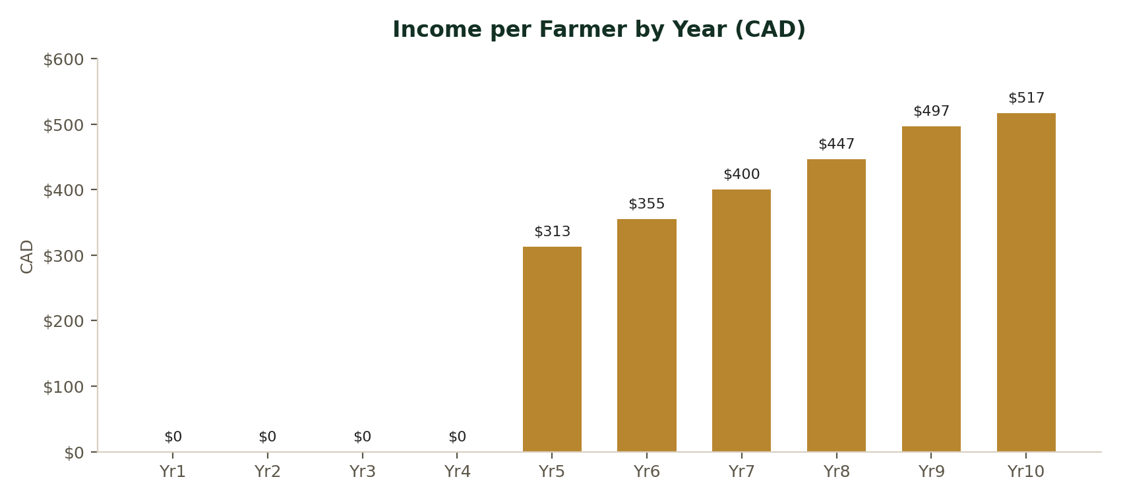
Income per farmer rises steadily from Year 5 onward, tracking the growth of the harvest itself, with no dips, no surprises.

To put that growth in real terms: our baseline survey found that farming families in this area currently earn about $552 CAD a year. Coconut income doesn't replace that, it adds to it, and by Year 10, that addition nearly doubles a family's total income, up 94%. Farmers may choose to plant additional trees which would significantly increase their income beyond what's shown here.
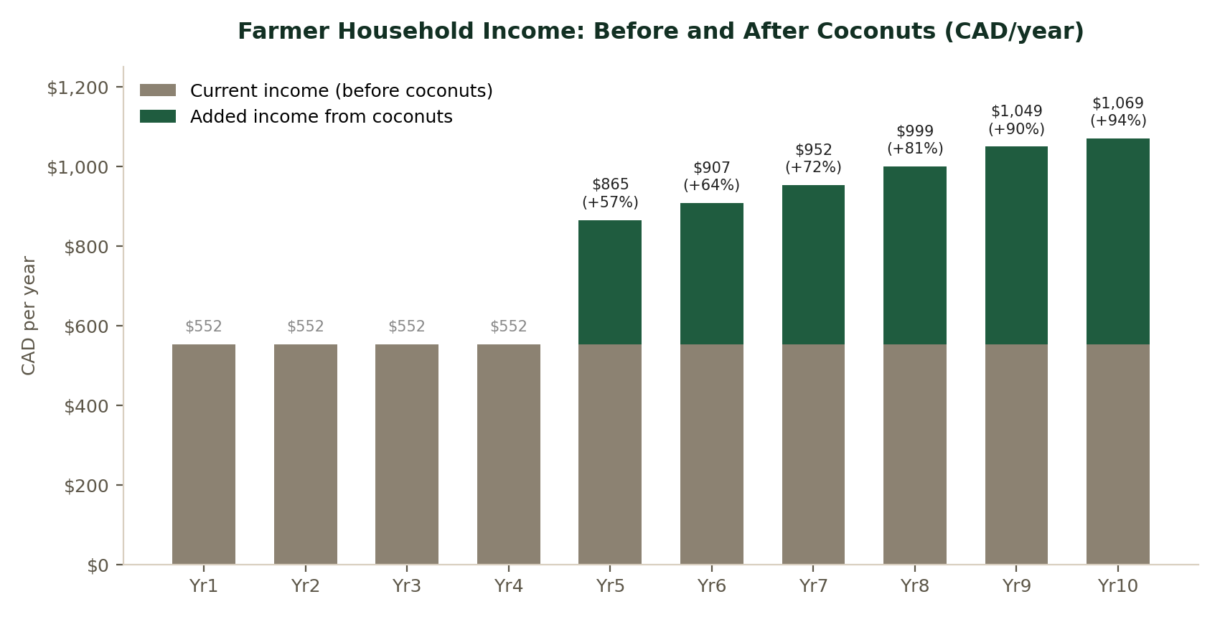
Increases in farmer income from coconut sales change what is possible for a family. It can make the difference between getting by and having room to choose: a better home, better food on the table, school fees paid on time. Instead of a source of stress, this additional income gives a family the ability to meet its household's priorities as they come up, not just provide for bare necessities. For 400 families, this is not a one-time cash injection, it's a standing improvement in what daily life can look like, and it keeps growing every year the trees keep bearing fruit.
WHERE THE PROFIT GOES
This is the commitment at the center of Plant the Future, unchanged by the phased approach. 80% of Liberia Foods Inc.’s profit is reserved for community development in Liberia, never for private benefit. Particular emphasis is placed on programs for women and girls, including scholarship support, women's cooperative leadership and income-generating opportunities, and health and family stability initiatives for women-led households.

WHY A PHASED APPROACH, WHY NOW
The land, the market, and the model are ready, and the trees are already going in; all 10,000 seedlings have arrived from Ghana and are being planted right now, with the plantation on its way to a full 18,000 trees. What a phased approach offers a founding donor is the ability to fund what's already proven, the plantation and the farmer relationships, while the case for the larger factory investment continues to build in real time, on the ground. We are early enough in this conversation that a founding donor's "fingerprints" and priorities can still shape how this project takes root, at either phase.
Plant the Future also marks a new chapter for Universal Outreach Foundation. It is larger in scale and more ambitious in structure than any initiative we have undertaken to date, moving beyond direct program delivery into building a self-sustaining commercial enterprise designed to generate lasting economic impact long after the campaign itself concludes. We see it as the next step in a broader effort to drive transformational, not just incremental, change in Liberia, and as the model proves itself here, we see a clear path to extending it into neighboring counties, multiplying this impact well beyond where it starts.

THE INVESTMENT
Plant the Future is structured as two funding decisions, each fully donation-funded, with no debt and no interest.
Total donor ask, 10-year | $2,463,209
Self-sustaining | Year 7, positive annual cash flow
Funding model | 100% donation-funded, no debt, no interest

Donor ask broken down by year:
 | Yr1 | Yr2 | Yr3 | Yr4 | Yr5 | Yr6 | Yr7 | Yr8 | Yr9 | Yr10 | Total
Donor ask | $178,280 | $191,097 | $136,827 | $281,567 | $537,666 | $948,160 | $189,612 | $0 | $0 | $0 | $2,463,209
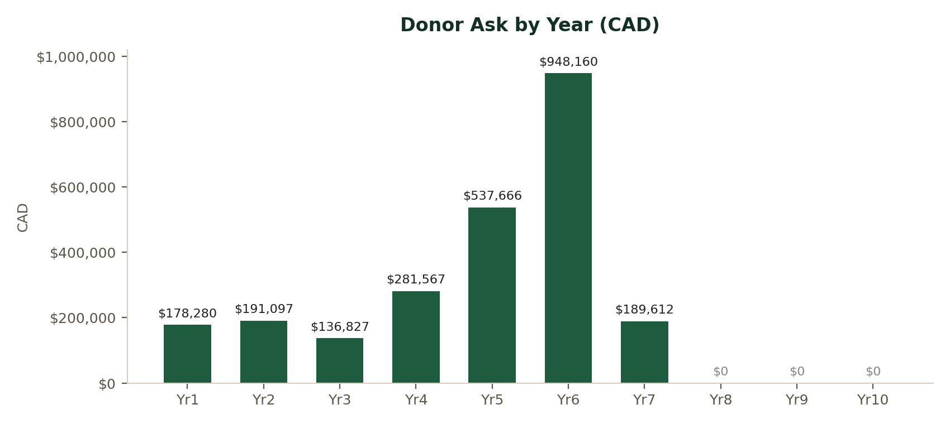
The ask drops to zero from Year 8. After this point the plantation and factory are generating sufficient revenue to cover operations without further donor support.
All figures in CAD. Capital for the factory is only drawn once the gating deliverables above are met.

LET'S TALK
This concept note is intentionally brief. We'd welcome the chance to discuss the full picture with you, including project financials, governance and ownership structure, sustainability and certification plans, and the phased timeline.

Kent Bubbs Jr.
Executive Director, Universal Outreach Foundation

